Capstone Project: Customer Purchase Behaviour:
- Field of focus: Management Information System (MIS)
- Problem statement:
I want to analyse/predict the user listening behaviour for Spotify using user streaming history, playlist activity, and listening preference data so that Spotify can make better recommendations, improve user retention, and increase user engagement.
- Expected output:
Improved user retention, higher engagement, and increased subscription revenue.

Capstone Proposal
This capstone project aims to analyze and predict user listening behavior on Spotify using user streaming history, playlist activity, and listening preference data. The study will explore patterns in how users interact with the platform, including their listening habits, genre preferences, and engagement levels. Through data analysis and predictive modeling techniques, the project seeks to identify factors that influence user behavior and provide insights that can enhance Spotify's recommendation system. The findings will support data-driven decision-making by helping Spotify improve user retention, increase user engagement, and ultimately drive higher subscription revenue through more personalized user experiences.
Economic Value of Project.
- Increased Customer Retention: By identifying users who are likely to become inactive or cancel subscriptions, Spotify can take targeted actions to keep them engaged.

- Higher Subscription Revenue: Understanding user behavior can help Spotify encourage free users to upgrade to Premium plans.

- Improved User Engagement: Better recommendations and playlists can lead to more listening time. More engagement often translates into stronger customer loyalty.

- More Effective Marketing: Customer segmentation allows Spotify to target specific groups with relevant campaigns. This can reduce marketing costs and improve campaign performance.

- Enhanced User Experience: Insights into listening habits help Spotify improve its recommendation algorithms and product features. A better user experience can increase satisfaction and retention.

- Data-Driven Decision Making: The findings can help management make informed decisions about content, features, partnerships, and promotional strategies.

Target:
spotify_subscription_plan
Cleaning steps:
- Find the sum of the missing values using the code: df.isna().sum()

Visuals and Metrics:
Columns in Data Set and Meaning:
- Spotify_usage_period: How long the user has been making use of Spotify.
- Spotify_listening_device: What device the user is uses to listen to Spotify.
- Spotify_subscription_plan : What kind of Spotify plan the user is making use of.
- premium_sub_willingness: How willing a user is to subscribe to Spotify Premium if they are not already a Premium user.
- preferred_listening_content: What kind of content the user listens to more often (music or podcast).
Project Timeline:
- Data Collection and Loading.
- Data Cleaning.
- EDA: Visualization.
- Modelling/ Testing.
- Interpretation.
- Presentation.
Documentation:
- Create virtual environment.
- Activate virtual environment:
- Install the following libraries:
  - For data collection and loading:
pip install pandas

  - For data visualization:
pip install matplotlib
pip install seaborn

  - For modelling and testing:
pip install scikit-learn

- Run pip list to see all installed libraries:
- Create the requirement.txt file to enable users of your project to easily download libraries required to work on project on their environment.

- Code body
    - Data Collection and Loading:
Code:
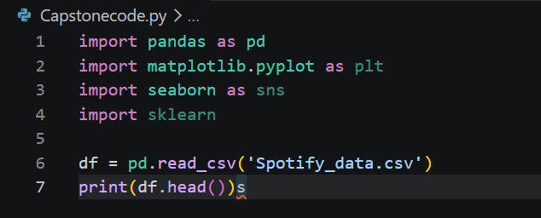
Updated

Output:
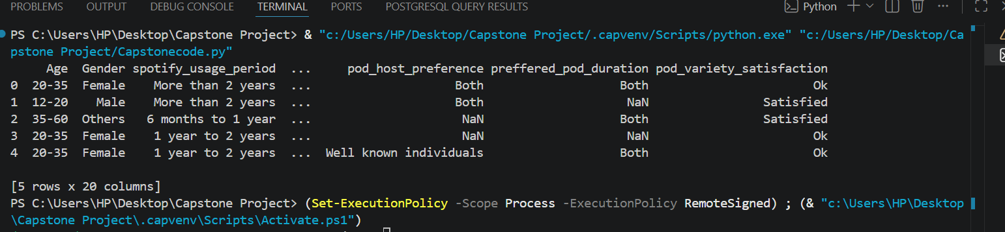

    - Data Cleaning:
- Check for missing values using the basic code:
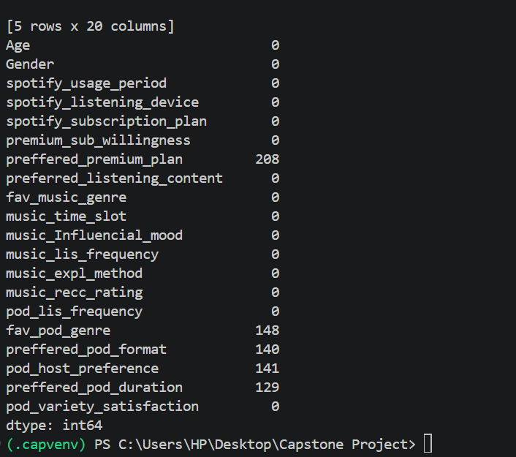
    - preffered_premium_plan 208
    - fav_pod_genre 148
    - preffered_pod_format 140
    - pod_host_preference 141
    - preffered_pod_duration 129

  - Check the missing values using the updated code:
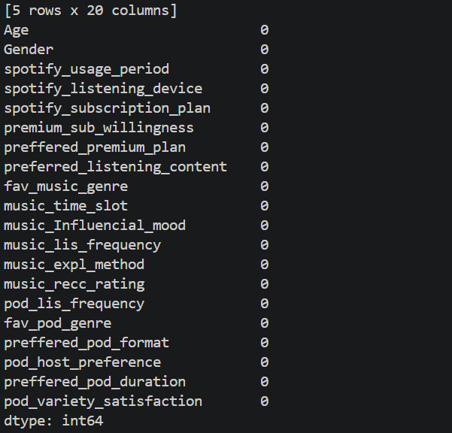

No data cleaning is required as there are no missing values to drop.

    - Summarizing:

    - EDA:
    - Visualization
    - Modelling/Testing:
    - Interpretation:
    - Presentation:

N.B:
1. self-collected or unupdated dataset on kaggle should not be used.
2. Kaggle has competitions for money.

Don’t use the Spotify dataset.
The higher the usability the lower the difficulty level to use the data set.

MIS is the intersection of business, tech and data.

